4th Transnational Meeting, Paris, 11-12 May 2022

Project presentation: 01.-RenovUp-General-Project-Presentation-EN.pdf / 01.-RenovUP-Presentation-generale-du-projet-FR.pdf

AGENDA

11 MAY 2022  10:00 – 11:30  11:30 – 13:00  13:00 – 14:00  14:00 – 15:30  15:45 – 17:15  17:15 – 18:00  20:00 | CONTENTS  CURRENT STATE OF PLAY: OUTPUTS, ACTIVITIES AND TIMELINES compared to initial engagements  Main productions available (Our shop window):  IO1-A1. In-depth analysis of the technical, organisational, and normative specificities of building renovation sites which affect the evolution of the functions of site managers and team leaders on these sites in the partner countries.  IO1-A2. Identification, in each partner country, of the specific skills expected of site managers and team leaders by companies specialising in building renovation.  https://www.renovup.org/wp-content/uploads/2022/03/00.-RenovUP_IO1_Transnational-Report-Final.pdf  IO1-A3. Design of national and modular systems for the professionalization of site managers and team leaders for building renovation sites identified in each partner country  https://www.renovup.org/wp-content/uploads/2022/03/00.-RenovUP_IO1_A3a-Work-situations-Corresponding-skills_Final-Report-EN.pdf  IO1-A3b&A4 / IO2-A1. Didactic tools for the professionalisation of site managers and team leaders for building renovation sites, designed in relation to work situations  https://www.renovup.org/wp-content/uploads/2022/04/10.-RenovUp-Didactic-tools-for-the-professionalisation-of-site-managers-and-team-leaders_Final-Report-EN.docx  IO2-A1 & IO2-A2. Transnational Synthesis of national Good Practices useful for Work-based Learning  https://www.renovup.org/wp-content/uploads/2022/04/00D.-RenovUP_IO2_National-Good-Practices-Transnational-Synthesis-Final.docx  Activities and Timelines:  OUTPUTS FROM THE OVIEDO & RADOM MEETINGS: Their potential implementation in each national context  LUNCH  OPERATIONAL PLAN FOR THE Implementation of experimental training courses for site managers and team leaders in connection with the training actions that already exist in the partner countries IN EACH PARTNER COUNTRY.  OPERATIONAL PLAN FOR the preparation of trainers, monitors & company tutors who will be involved in the training of site managers and team leaders IN EACH PARTNER COUNTRY.  ADVICE AND GUIDANCE FROM THE EXTERNAL EVALUATOR ON THE WORK PROGRESS  SOCIAL DINNER (OFFERED BY CCCA-BTP)

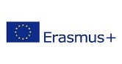
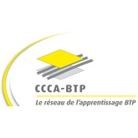
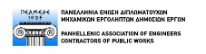
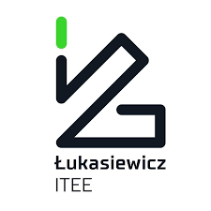
FR
GRece
PL
IT
ES
4th Transnational Meeting, Paris, 11-12 May 2022

AGENDA

12 MAY 2022  09:00 – 09:30  09:30 – 11:00  11:15 – 12:30  12:30 – 13:00  13:00 | COMMENTS ON DAY 1  Communication strategies to be implemented in each partner country to disseminate and valorise the project results  ADMINISTRATIVE AND FINANCIAL ISSUES  ADDITIONAL ISSUES AND ORGANISATION OF THE NEXT MEETING  BUFFET (SANDWICHES)

