IO2 – A1 & A2
Creation of a transnational device to evaluate and validate the learning outcomes of site managers and team leaders for building renovation projects

Draft document prepared by the CCCA-BTP
Transnational meeting Paris 11 and 12 May 2022

Two Open Badges for RenovUp

In the framework of the RenovUp project, the use of Open Badges can be envisaged for two distinct audiences:

- TRAINERS RESPONSIBLE FOR THE PROFESSIONALIZATION OF BUILDING RENOVATION SITE MANAGERS AND TEAM LEADERS (Link with IO3) - Open Badge 1

- OBJECTIVE: To recognise the successful participation of these trainers in all the modules within the framework of the "preparation for the animation of the professionalization system of the targeted site managers and team leaders".
By issuing a specific Open Badge 1, the aim is to recognise that the trainers have successfully completed a training session in each partner country to prepare them to use the teaching methods and tools (grids and procedures) specifically developed and made available to them to enable them to run the professionalisation scheme for the target groups. Obtaining this badge will indicate that they are ready, thanks to participation in the training session, to implement the training sessions in question.

- SITE MANAGERS AND TEAM LEADERS WHO HAVE PARTICIPATED IN THE RENOVUP PROFESSIONALISATION FACILITY (Link to IO1-A3 and IO2-A1) - Open Badge 2

- OBJECTIVE: To recognise the mastery of the major blocks of skills targeted by the professionalisation scheme for the public concerned.
Pre-requisite for the issuance of the Open Badge: completion of the training components that lead to the mastery of the competencies to be recognised.
To identify the contents of the Open Badge 2 in terms of the competences to be recognised, two variants are possible:

 | VARIANT 1 | VARIANT 2
Origin | Grids for the observation of work situations in renovation companies experienced by site managers (Grid 1) and team leaders (Grid 2) | Grid 4 for assessing learner progress
Nature | SEQUENTIAL approach, with competences per phase of the work (as favoured in the training scheme) | Direct approach by large blocks of TRANSVERSAL competences (mix between assessment and recognition perspective)
Competencies  to be recognised with Open Badge 2 | 1: Skills to prepare a renovation site | 1: Monitor and control the work process and the quality of productions
 | 2: Skills for managing communication and relationships on a renovation site | 2: Taking responsibility and performance
 | 3: Skills to manage the technical and organisational aspects of a renovation site | 3: Forecasting and planning
 | 4: Competence to ensure the acceptance of the renovation works and the quality control final | 4: Organising work and managing human resources

Whatever variant is chosen for Open Badge 2 (to be decided during the transnational meeting on 11 and 12 May 2022 in Paris), the CCCA-BTP will then have to work on the following aspects

- Formal and editorial elements

Each open badge must be specifically identified, described, and written down.
- It is important to clearly identify what the open badge recognises and to formulate an explicit and engaging title.
- It is necessary to describe precisely what is recognised in terms of competences and what are the chosen criteria for recognition.
- It is necessary to create or choose a suitable visual medium that is meaningful and attractive.

Example: Transcription of a content from grid 4 into an Open Badge

GRID 4 | ASSOCIATED OPEN BADGE
COMPETENCE | TITLE OF OPEN Badge associated
Monitor and control the work process and the quality of productions | Competent to monitor and control a renovation project
COMPONENTS of the COMPETENCE (taken from Grid 4) | CRITERIA FOR OBTAINING AN OPEN BADGE
Production process | Ability to identify critical points, quality criteria and develop specific control procedures to ensure the quality of the whole production process, including unplanned work.
Cost | Ability to control costs in relation to the material used (quality and quantity), in relation to forecasts.  Ability to control human costs in relation to staff productivity.
Time | Ability to monitor, regulate and regularly adapt scheduled activities and tasks to the situations encountered.
Documents and planned security status | Ability to identify and collect all administrative, financial, legal and safety-related documents on renovation sites.  Ability to identify specific situations critical to the health and safety of workers.

The right-hand column of the above table should give both the holder of the open badge and the person discovering it an overview of its contents.
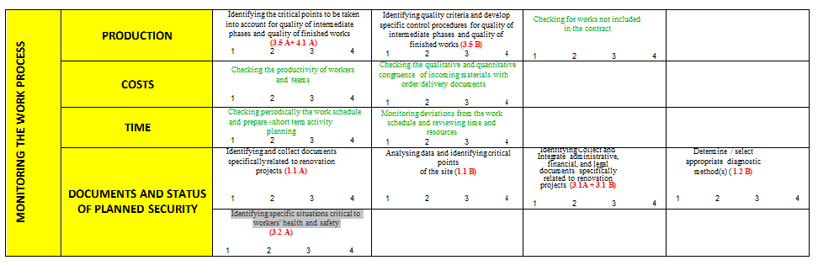
Each criterion written in the right-hand column is a summary of the "white" boxes in grid 4 below:

- Proposals for governance (national and transnational)

The CCCA-BTP currently owns and uses a paid Open Badge account that can be used for the RenovUp project. Here we can create an unlimited number of badges and assign them to as many people as we wish. This can only be an intermediate solution, to be used during the RenovUp project in its experimental phase.

Once the project is finished, it will be necessary to propose the sustainability of the system:
- Open Badge 1 for trainers ;
- Open Badge 2 for trainees.

The CCCA-BTP, as the pilot of IO2, proposes :

- Remain the issuing body for Open Badge 1, with a RenovUp label, for 5 years after the end of the project, which would allow a natural extension of the project, a light periodic consultation between the partners to keep in touch and to continue to collaborate (one of the objectives of KA2 - Erasmus+).

- Identify immediately national organisations (professional federations, training networks or others) capable of delivering the Open Badge 2, developed by the RenovUp partners with a common visual, methodology and content. These national organisations would hold each national Open Badge 2. The cost of this ownership remains to be evaluated (it is not prohibitive).

- Proposed organisation

- All the partners are working together to create the content of the badges (titles, description, eligibility criteria, etc.) and agree on the approximate number to be issued in each country over the next three years. While working on this, it will be necessary to think about the recipients of the Open Badges (trainees, but also companies, organisations validating formal and non-formal skills, etc.).

- All partners choose a site dedicated to the creation of Open Badges (Open Badge Factory, Openbadger or other) and develop a common visual.

- Each organisation identified as a national Open Badge holder opens a paying account (about 600 €/year in France) on the chosen site and recreates the badges in its national language. A bilingual form is also possible.

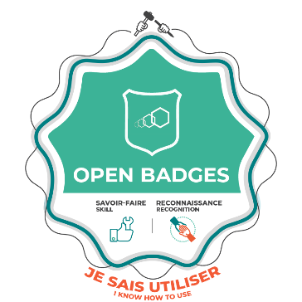
Open Badge 2 created by all partners (Title, content, description, visual, award criteria)

Each country creates its own account and duplicates the jointly designed Open Badge

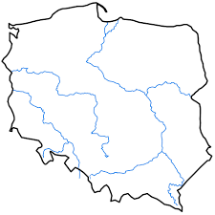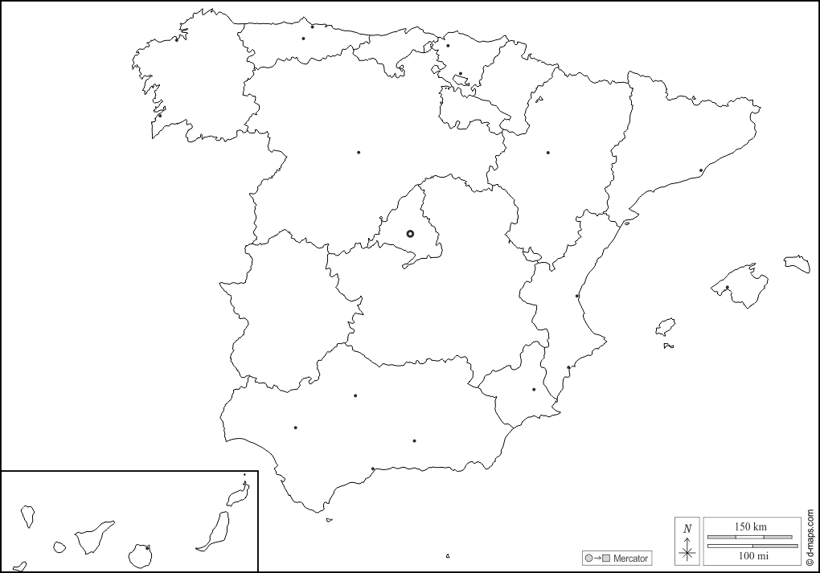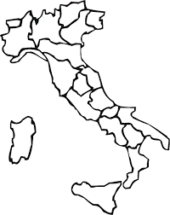
Each beneficiary receives and distributes it according to his or her wishes and needs.

Technical alert point :

When an Open Badge is issued with Open Badge Factory, the holder receives an alert by email and must then create a "backpack" in which all his open badges will be stored.

To share this Open Badge, the holder chooses whether to make them public or not and can also share them in a targeted way to specific people by sending a digital link. This link can also be inserted in a CV or an email.

It is therefore necessary to inform each future recipient of an Open Badge of these singular points. An Open Badge will only be of value if the holder knows how to use and value it. The Open Badge culture is not yet well developed, and it is necessary to do everything possible to initiate and accustom the beneficiaries to their use.

For example, consideration could be given to creating an information campaign for the various partners in the profession on Open Badges in the partnership countries.

See the document "Didactic tools for the professionalisation of site managers and team leaders for building renovation sites, designed in relation to work situations TRANSNATIONAL REPORT" available at https://www.renovup.org/general-overview-io2/

