

Contract Nb. 2020-1-FR01-KA202-080105 (2020-2023)

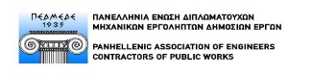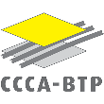

**5th Transnational Meeting, Rome - Minutes**

November 22nd (09:00 – 18:00) and 23rd (09:00 – 13:00), 2022

|  |  |
| --- | --- |
| **Topics** | |
| 1. | setting up & TESTING EXPERIMENTAL TRAINING PATHWAYS : State of play (FLC ASTURIAS & CCCA-BTP) |
| 2. | preparing trainers, monitors & company tutors (ŁUKASIEWICZ ITeE & CCCA-BTP) |
| 3. | ADVICE AND GUIDANCE FROM THE EXTERNAL EVALUATOR ON THE WORK PROGRESS  Partners' views |
| 4. | EXPLOITATION AND DISSEMINATION strategies to be implemented in each partnerSHIP country (CCCA-BTP) |
| 5. | ADMINISTRATIVE AND FINANCIAL ISSUES |
| 6. | ORGANISATION OF THE NEXT MEETING |

|  |  |
| --- | --- |
| **Participants** | |
| **BTPCFA PAYS**  **DE LA LOIRE (FR)** | Dreyfus Philippe philippe.dreyfus@btpcfa-pdl.com |
| **CCCA-BTP (FR)** | Beauchesne Marion [marion.beauchesne@ccca-btp.fr](mailto:marion.beauchesne@ccca-btp.fr) - online (2nd day only)  Lawinski Marek [marek.lawinski@ccca-btp.fr](mailto:marek.lawinski@ccca-btp.fr)  Picot Isabelle [isabelle.picot@ccca-btp.fr](mailto:isabelle.picot@ccca-btp.fr)  Touillon Pierre [pierre.touillon@ccca-btp.fr](mailto:pierre.touillon@ccca-btp.fr) |
| **FLC ASTURIAS (ES)** | Hevia Fano Marta [mhevia@flc.es](mailto:mhevia@flc.es)  Alba Garcia Sandra salba@flc.es |
| **FORMEDIL (IT)** | Degisi Diego [diegodegisi@formedil.it](mailto:diegodegisi@formedil.it) - online  Linari Antonella [antonella.linari@formedil.it](mailto:antonella.linari@formedil.it)  Macale Stefano [stefano.macale@formedil.it](mailto:stefano.macale@formedil.it) |
| **ITE ŁUKASIEWICZ (PL)** | Koprowska Dorota [dorota.koprowska@itee.lukasiewicz.gov.pl](mailto:dorota.koprowska@itee.lukasiewicz.gov.pl)  Religa Jolanta [jolanta.religa@itee.lukasiewicz.gov.pl](mailto:jolanta.religa@itee.lukasiewicz.gov.pl) |
| **PEDMEDE (GR)** | Damianou Eleni [e.damianou@pedmede.gr](mailto:e.damianou@pedmede.gr) - online  Kontomichali Margarita [m.kontomichali@pedmede.gr](mailto:m.kontomichali@pedmede.gr)- online |
| **PREFACE (FR)** | Roux Sébastien [contact-preface@sfr.fr](mailto:contact-preface@sfr.fr) |

5th transnational meeting, Rome: Work first, but also the pleasure of being together ...

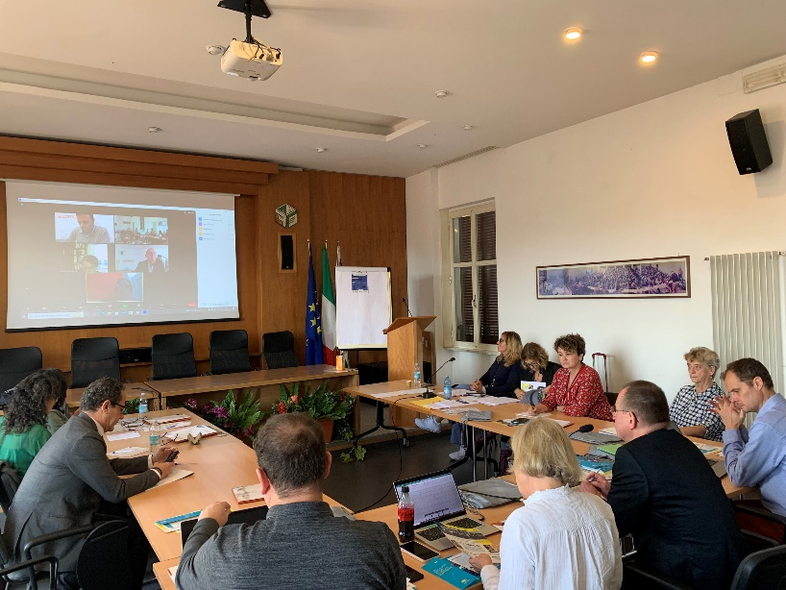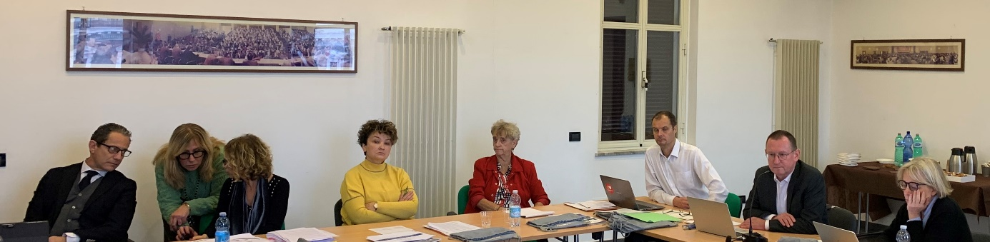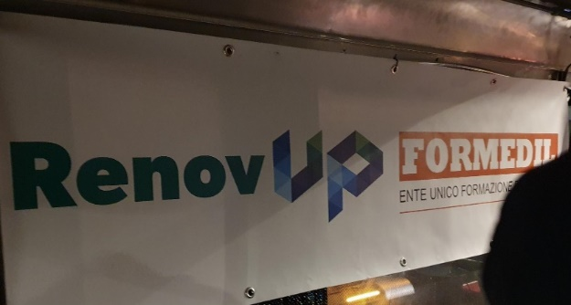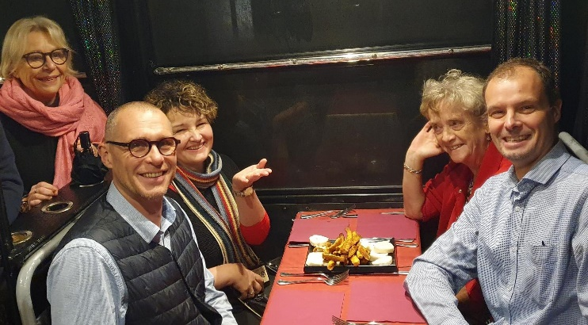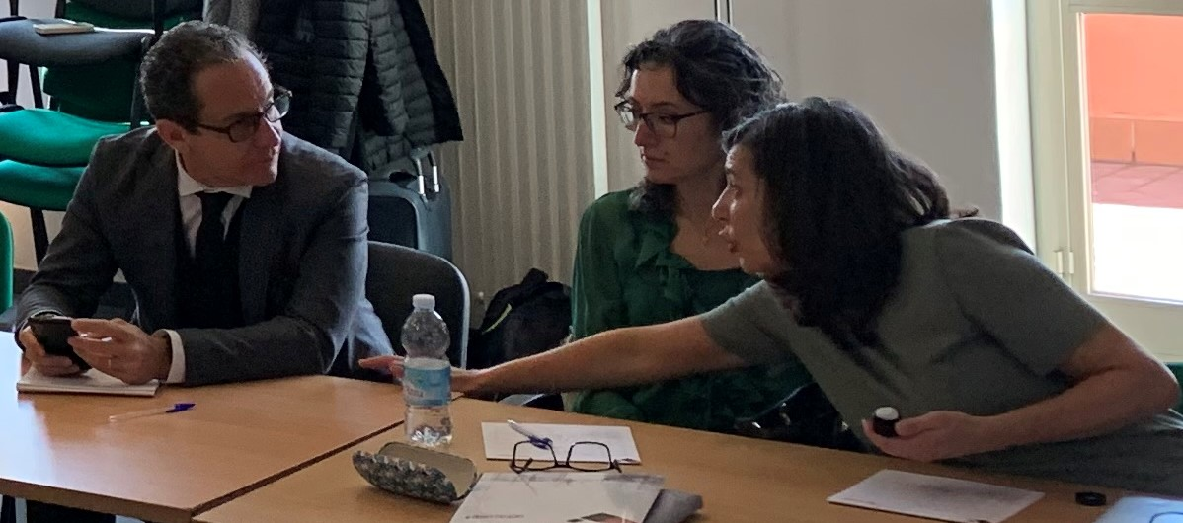

|  |  |
| --- | --- |
| **1.** | **setting up & TESTING EXPERIMENTAL TRAINING PATHWAYS : State of play (FLC ASTURIAS & CCCA-BTP)** |

**State of the art**

The partners plan relatively heterogeneous experiments which are presented in the compilation entitled "IO4: Transnational strategy and national systems for the positioning, support and professionalisation of site managers and team leaders for building renovation sites; PREPARATION OF EXPERIMENTAL TRAINING ACTIONS - STATE OF THE ART AS OF 15 NOVEMBER 2022", available at [www.renovup.org](http://www.renovup.org), Intellectual Outcomes 4.

The summary of the planned experimental trainings:

* Actions planned in Spain
* Experimentation 1: Group of 6 site managers
* Experimentation 2: Group of 6 team leaders
* Actions planned in Poland
* Experimentation with 10 individual learners, training planned directly in several companies from various regions.
* Actions planned in Italy
* Experimentation 1: Group of 6 site managers
* Experimentation 2: Group of 6 team leaders
* Actions planned in France (systemic approach, based on existing initial training programmes that will evolve)
* Experimentation 1: Group of 15 site managers (Pays de la Loire)
* Experimentation 2: Group of 8 team leaders (Blanquefort)
* Experimentation 3: Group of 6 team leaders (Pays de la Loire)
* Actions planned in Greece
* Experimentation to be specified, based on continuing training (10 participants), in collaboration with a training centre situated in Athens.

The project is becoming more and more systemic, and the partners realise that it will be difficult to separate, in practice, the phases of observation of professional situations in companies, their translation into specific pedagogical objectives, the positioning of learners on entry to training and the evaluation of their progress. The experimentation will also have to focus on the simultaneous use of the tools created, while considering the specificity of the training paths chosen in each country.

It was pointed out that the central theme of the experimental actions is the analysis and learning from professional situations in the field of building renovation.

Training of trainees and training of trainers will also be closely linked.

**Timelines and decisions taken:**

* **The experimentations must be concluded before 31 May 2023. A minimum of four components must be tested.**
* The duration of each component/block will be determined by each partner organisation, according to the targeted learning outcomes.
* Beneficiaries and companies to be identified if not already done.
* The partners do not target a specific formal qualification, but a recognition of new skills and competences with appropriate Open Badges : one per block with more than 50% of components per block (ex. If only two components in one block, both are mandatory for the Open Badge), if four Open Badges obtained, one GLOBAL OPEN BADGE will be delivered
* Each partner will identify a national body to issue the appropriate national OPEN BADGES, with a specific account to be opened with an accredited organisation.
* It is essential to specify the added value of the Open Badges compared to existing national training standards and qualifications frameworks. Question to be answered: Who would validate the competence?
* Link with micro-credentials, as described in the European Skills Agenda, to be considered.
* CCCA-BTP to finalise the model **before 31 January 2023.**
* **The model for the analysis of the national experimental actions to be prepared (FLC Asturias together with CCCA-BTP) – before 31 January 2023.**

|  |  |
| --- | --- |
| **2.** | **preparing trainers, monitors & company tutors (ŁUKASIEWICZ ITeE & CCCA-BTP)** |

The partners communicated their training/coaching projects to the CCCA-BTP before the Rome meeting. The results were compiled in the report "IO3: Transnational training scheme for teachers, trainers and tutors preparing for the support and training of site managers and team leaders for building renovation sites NATIONAL EXPERIMENTAL ACTIONS – State of the Art 15 November 2022" available at [www.renovup.org](http://www.renovup.org), Intellectual Outcomes 3. These are partial results, as not all countries are progressing at the same pace.

**Issues raised and decisions taken:**

* A precise schedule for coaching trainers in each partnership country must still be defined more precisely.
* It is also to be defined which national organisations would be able to train. To avoid misunderstandings and too formal frameworks, especially in the countries where a specific accreditation is required, it is advised not to use the term of “TRAINING” but rather “MONITORING” or “GUIDANCE”. Thus, the following organisations would provide trainers with this guidance:
* Spain: FLC Asturias
* Italy: FORMEDIL
* Poland: LUKASIEWICZ ITeE
* France: CCCA-BTP
* The monitoring/guiding of trainers must take place simultaneously with the training of trainees for two main reasons:
* Not to be behind schedule compared to contractual deadlines.
* To guarantee a practical analysis of concrete learning situations experienced with specific trainees.
* **The general framework and methodology will be the same for all countries, as proposed by LUKASIEWICZ ITeE and CCCA-BTP in the booklet listed above.**
* **Deadlines will be aligned with the training of trainees:** Each partner begins training when it is ready, but in any case, **before March 2023** (e.g., Italy begins in mid-January 2023).
* The position of trainer of trainers must be clarified in each country before the action begins.
* **Modification of STAGE 1 to be considered:**
* Presentation of the four grids in a systemic approach from the beginning.
* Collection of impressions and points of view expressed by the participants (trainers).
* The pedagogical objectives should be addressed from the beginning (entry by the meaning and not by the tool).
* Main issue: Reflection on how to transform the observations of the work situations into learning objectives and what is needed in terms of appropriate components to achieve the learning objectives.
* Main outcome of STAGE 1: Formulation of good tips and tricks for designing learning content to serve the learning objectives, followed by identification of learning content and methods.

**Reminder**

**Stage 1**

f2f meeting at school/training centre

(Suggested 2 days)

**Stage 3**

f2f meeting at school/training centre

(Suggested 1 or 2 days)

**Stage 5**

f2f meeting at school/training centre (Suggested 1 or 2 days)

* RenovUp's offer for the construction staff (general presentation)
* Familiarisation with Grids 1&2 for observation and analysis of work situations
* Tips for pedagogical objectives
* Familiarisation with Grid 3 for diagnosing training needs of trainees
* Familiarisation with Grid 4 for progress evatuation
* Tips for pedagogical objectives
* Open Badges
* General feedback
* Tips for pedagogical objectives

**Stage 2**

Observation and analysis of work situations with

Grids 1 & 2 on Renovation sites (1 or 2)

Suggested ½ or 1 day

**Stage 4**

Identification and analysis of the learner’s progress with

Grids 3 & 4 (or future consolidated grid) at school or on Renovation sites (1 or 2)

Suggested ½ or 1 day

Suggested duration: 5 months maximum

*Source: Łukasiewicz ITeE (2022)*

* **Further to the modification of STAGE 1, also STAGE 2 (observation of work situations in companies) should be revised.** E.g., Grid 3 can be tested out of the first visit in company.
* **ONLINE MEETING TO BE SCHEDULED AFTER STAGE 1 – PREFERABLY MID-FEBRUARY 2023.**
* The learning outcomes will be recognised with **Open Badges**:
* The first one will be issued after STAGE 2 (first observation and analysis of work situations in companies).
* The second will be global and will be issued after STAGE 5 (final), following the production of reflections and pedagogical results.
* The CCCA-BTP will be the organisation that will issue these Open Badges for all partners.
* **A final proposal will be made by the CCCA-BTP by the END OF FEBRUARY 2023**.

|  |  |
| --- | --- |
| **3.** | **ADVICE AND GUIDANCE FROM THE EXTERNAL EVALUATOR ON THE WORK PROGRESS**  **Partners' views** |

**Opinion**

* The main question now is how to use the remaining time: Test the models created.
* The reality principle must be applied: Do not commit to steps that are not realistic in the specific national contexts. Grids 1, 2, 3 and 4 should be seen as starting points, where modifications could be made according to the reality principle.
* Open Badges: This innovation brings added value to the project and should be tested for sure.
* WHAT SHOULD BE EXPECTED FROM THE EXPERIMENTATION?

🢥Indicate what needs to be improved, adjusted, removed, or added for the results to be useful and ready to be disseminated at a wider level in national and transnational contexts.

* Do not forget the specificity of the project: BUILDING RENOVATION.

**Main decisions approved by the Evaluator (Sébastien):**

* The tests must be completed by the end of May 2023 at the latest.
* Experiment with at least 4 components for trainee training.
* Organise an online meeting after the first stage (mid-February). Jola: mid-February is too late. Answer: don't wait, but we will do this online meeting once all countries have done step 1.
* Open Badge for trainers, option 2: 1 Open Badge after session 2 and 1 global badge.
* Design the 2 OBs for trainers by mid-February and test them after the end of the experiment for trainers (this will be possible then).
* CCCA-BTP will create the Open Badges and open access to the other partners on Open Badge Factory: this access will be free. What would be paid for would be the creation of OBs, but not the use of OBs created by the CCCA-BTP. The visual identity will be a "RenovUp" identity.
* Each partner will send the guidelines and recommendations for dissemination in their area by mid-March.
* Save the date: the last 3 events will take place from 14 to 16 June in Nantes (last technical meeting, last dissemination event, exchange of practices between trainers).
* Marion is making regular reminders to partners to fill in the valorisation journal.

**Partners' views**

* Complexity of the process in Greece and Poland.
* Added value of Open Badges, particularly new in Italy.
* Importance of testing in each country: The process to be put in place is clearer thanks to this meeting.
* The differences existing in each country must be considered. Example: The implementation of individualised training paths in Poland.
* Doubts about how to proceed with trainers (training and observation of work situations in companies).
* Understanding the potential difficulties of each partner is essential for the success of the test phase.
* Despite some difficulties identified for the implementation of the experimental phase, confidence in the continuation of the project.

|  |  |
| --- | --- |
| **4.** | **EXPLOITATION AND DISSEMINATION strategies to be implemented in each partnerSHIP country (CCCA-BTP)** |

**Remider**

It is foreseen in the initial contract that the partners would achieve the following actions:

* At least one **Multiplier (dissemination) event** in each partnership country must be organised before the contractual end of the project (**31 August 2023**), with at least 35 participants. The budget dedicated to this is based on the following rules:
* 100 € of EU grant for each national participant.
* 200 € of EU grant for each non-national participant (project partner organisations are not eligible).
* Initial budget (reminder):

|  |  |  |  |  |  |  |
| --- | --- | --- | --- | --- | --- | --- |
|  | CCCA-BTP FR | FORMEDIL IT | FLC ASTURIAS ES | LUKASIEWICZ PL | PEDMEDE GR | TOTAL |
| Multiplier  Events | 8 000 € | 5 000 € | 5 000 € | 6 500 € | 5 000 € | 29 500 € |

* So far, three events took place in 2022: **two in Poland and one in Spain**. They can serve as an example of good practice for other partners (more information available at [www.renovup.org](http://www.renovup.org)).
* Each partner has been assigned a specific transversal task, at the service of all the partners, regarding the common communication strategy:
* **CCCA-BTP (FR)** will propose strategies for the promotion of new modes of collaboration with companies and training in work situations within the framework of the envisaged professionalisation schemes.
* **Formedil (IT)** will propose strategies and modes of communication to promote transparency, recognition, and validation of learning outcomes.
* **Łukasiewicz ITee (PL)** will propose communication approaches to promote the training of teachers/trainers/tutors in enterprises.
* **FLC Asturias (ES)** will oversee developing communication strategies with external organisations capable of facilitating the recruitment of beneficiaries of the planned professionalisation actions.
* **Pedmede (GR)** will be in charge of proposing communication strategies of a more institutional nature, aimed at political and strategic decision-makers, mainly to ensure that the results of the project can be used beyond its partners.

The proposals, in the form of guidelines, of three to four pages maximum per theme, must be inspired by the experiences of the RenovUp project. **The partners agree to do this work by mid-March 2023**, and the CCCA-BTP will also be responsible for drawing up a summary.

* It was also recalled that it is important to systematically update the **Valorisation Journal**, to better monitor the communication, dissemination, and exploitation of results.

|  |  |
| --- | --- |
| **5.** | **ADMINISTRATIVE AND FINANCIAL ISSUES** |

Global review:

The table attached lists the information provided by the project’s partners on the time spent on the project.

Column C shows the amount of time that was foreseen for each partner and for each intellectual outcome in the initial contract.

The cells highlighted in yellow show the time deficits on certain productions which will have an impact on the final grant of the partners concerned but the consumption of working days between the different intellectual productions can partly compensate each other.

Key points:

**IO1**: CCCA-BTP, FLC Asturias, Lukasiewicz: overconsumption

**IO2**: FORMEDIL, PEDMEDE: more than 80% of unused days

**IO3**: PEDMEDE 100% of unused days

|  |  |
| --- | --- |
| **6.** | **ORGANISATION OF THE NEXT MEETING** |

The final project meeting will take place at a construction training centre near **Nantes, France, from 14 June (9am) to 16 June (4pm) 2023**, which means travelling the day before and leaving the day after.

This meeting will have three main points, forming a whole:

* Transnational Multiplier / Dissemination Event (14 June 2023)
* Exchange of good practice between trainers and other stakeholders involved in RenovUp or concerned by the project outcomes (15 June 2023).
* 6th Transnational/Final meeting (16 June 2023).

More information will be transmitted in March 2023.

**Deadlines starting from 1st of December 2022**

|  |  |
| --- | --- |
| **Before 31 January 2023**  **January to end of March 2023**  **Mid-February**  **End of February**  **End of May 2023**  **Before 31 May**  **14 to 16 June**  **31 August 2023** | **Object**: Finalisation of the analysis model of the national experimental actions  **Partners concerned**: CCCA-BTP (FR), FLC ASTUIAS  **Object**: Beginning of trainings of trainees  **Partners concerned:** All partners, Formedil (IT) begins in mid-January 2023  **Object:** online meeting (after Stage 1)  **Partners concerned:** All  **Object:** Final proposal, learning outcomes recognised by Open Badges  **Partners concerned**: CCCA-BTP  **Object:** completion of the tests  **Partners concerned:** All  **Object**: conclusion of the experimentations. A minimum of components must be tested  **Partners concerned**: All  **Object:** last technical meeting, last dissemination event, exchange of practice between trainers Nantes/France  **Partners concerned:** All  **Object:** Multiplier (dissemination) event in each partnership country with at least 3 participants  **Partners concerned**: All |