

**Professionalising site managers and team leaders in the specific management**

**of building renovation sites in Europe**

Contract Nb. 2020-1-FR01-KA202-080105 (2020-2023)



**IO2: Transnational system for the assessment and recognition of the learning outcomes of site managers and team leaders for building renovation sites with Open Badges**

**IO2 Recognition of Learning Outcomes with Open Badges**

**(Final Proposal)**



Drafted by CCCA-BTP

Paris, 24 February 2023

**Table of content**

**General Framework** 3

**Implementation** 4

**TRAINERS/TEACHERS: OPEN BADGE 1** 5

**RENOVATION SITE MANAGER: OPEN BADGE 2** 7

**RENOVATION TEAM LEADER: OPEN BADGE 3** 12

**Possible graphic shapes** 17

**Procedure to deliver an Open Badge (Example)** 18

**Disclaimer**

*The European Commission's support to produce this publication does not constitute an endorsement of its contents, which are the sole responsibility of the authors, and the Commission cannot be held responsible for any use which may be made of the information contained therein.*

# **General Framework**

The recognition of learning outcomes foreseen will be made with Open Badges 1 (for trainers) and 2 (for trainees: renovation site managers and team leaders). "Open Badge should not be equated with a certificate or a diploma. It should be easily shared on social networks, on Linkedin, on a CV, etc. It is in no way a question of competing with diplomas, but of highlighting skills that are neither validated nor valued more formally. Therefore, these Open Badges would allow great flexibility by recognising specific pedagogical (trainers/teachers) and transversal (trainees) skills, related to training paths intended to renovation site managers and team leaders.

1. **TRAINERS/TEACHERS RESPONSIBLE FOR THE PROFESSIONALIZATION OF BUILDING RENOVATION SITE MANAGERS AND TEAM LEADERS** - Open Badge 1

OBJECTIVE: To recognise the successful participation of these trainers in all the modules within the framework of the "preparation for the animation of the professionalization system of the targeted site managers and team leaders".

By issuing a specific **Open Badge 1, with two levers (Professional and Expert)**, the aim is to recognise that the trainers have successfully completed a training session in each partner country to prepare them to use the teaching methods and tools (grids and procedures) specifically developed and made available to them to enable them to run the professionalisation scheme for the target groups. Obtaining this badge will indicate that they are ready, thanks to participation in the training session, to implement the training sessions in question.

* **Open Badge 1 – level 1 (Professional)** will be issued after STAGE 2 (first observation and analysis of work situations in companies).
* **Open Badge 1 – level 2 (Expert)** will be global and issued after STAGE 5 (final), following the presentation of reflections and pedagogical results.

**TRAINEES**

OBJECTIVE: To recognise the mastery of the blocks of skills targeted by the professionalisation scheme intended to renovation site managers.

The partners do not target a specific formal qualification, but a recognition of new skills and competences with appropriate four Partial Open Badges : one per block with more than 50% of components per block (Ex. If only two components in one block, both are mandatory for the Open Badge), if four Open Badges are obtained, the final GLOBAL OPEN BADGE will be delivered.

Conditions for issuing **Open BadgeS 2** (renovation site managers) **& 3** (team leaders):

* Completion of the training elements leading to the mastery of the competences to be recognised.
* Presentation of appropriate productions to be considered as evidence of these competences.

Access by positioning and validation of skills (following an interview with presentation of evidence) will also be possible.

1. **SITE MANAGERS WHO PARTICIPATED IN THE RENOVUP PROFESSIONALIZATION SCHEME** - Open Badge 2
2. **TEAM LEADERS WHO PARTICIPATED IN THE RENOVUP PROFESSIONALIZATION SCHEME** - Open Badge 3

# **Implementation**

Before the training period (for trainers and trainees), it is necessary to inform each learner about the possibility of recognising all or part of the learning parts and outcomes with Open Badges. It is advisable to inform them about the procedure and methods of recognition as well as about the interest of obtaining and accumulating the planned Open Badges. Therefore, it is essential to specify the added value of the Open Badges compared to existing national training standards and qualifications frameworks.

For renovation site managers and team leaders, we propose that it should be possible to give access to the planned **Open Badges by equivalence**, if the evidence of the competences to be acquired at the end of each block is provided during the interviews to be set up in each country. We believe that this could help to raise awareness of the proposed Opens Badges and to make them more widely used.

To simplify the delivery of Open Badges in 2023 and 2024 (even if the RenovUp project will be finished), the CCCA-BTP will take charge of the subscription to **Open Badge Factory, "Premium" level of service** (680 €/year) for all the project partners. With this subscription, it will be possible to create an unlimited number of badges (we need to create twelve, see details below, in English, French, Spanish, Italian, Polish and Greek, i.e. seventy-two versions in total), for 15,000 beneficiaries per year, which seems to largely meet our needs.

[Why OBF? - Open Badge Factory](https://openbadgefactory.com/en/)

Each partner will be able to enter data and disseminate its Open Badges at its national level. The only condition is that the Open Badges must be distributed in their initial form (the proposed design below is not final, it is being finalised in consultation with the CCCA-BTP communication department), without the possibility of modifying it autonomously, without consultation with the CCCA-BTP.

### **TRAINERS/TEACHERS: OPEN BADGE 1**



**Level 1**



|  |  |  |
| --- | --- | --- |
|  | Common/transnational skills/competences to be recognised with Open Badge 1 | **Conditions for the award of Open Badge 1**  **(Evidence to be provided)** |
| STAGE 1:  Understanding work-based learning for renovation site managers and team leaders. | 1. Knowing the national training system addressing middle managers for renovation sites. 2. Knowing the main principles of the work-based learning. 3. Mastering the main principles, methods, and tools for observing and analysing work situations that can be integrated into the learning processes. | 1. Having **participated** in Stages 1 & 2 in full (including at least one analysis of work situations). 2. Having **presented** the following outcomes:  * Analysis of the work situations observed for the further integration to the learning (or training) process. * Initial evaluation of the learner’s skills observed. |
| STAGE 2:  Analysing work situations in companies and integrate them into the vocational training process with appropriate tools. |

**Recognising organisations**: National bodies

**Level 2**



|  |  |  |
| --- | --- | --- |
|  | Common/transnational skills/competences to be recognised with Open Badge 2 | **Conditions for the award of Open Badge 2**  **(Evidence to be provided)** |
| STAGE 1:  Understanding work-based learning for renovation site managers and team leaders. | 1. Knowing the national training system addressing middle managers for renovation sites. 2. Knowing the main principles of the work-based learning. 3. Mastering the main principles, methods, and tools for observing and analysing work situations that can be integrated into the learning processes. | 1. Having **participated** in Stages 1 & 2 in full (including at least one analysis of work situations). 2. Having **presented** the following outcomes:  * Analysis of the work situations observed for the further integration to the learning (or training) process. * Initial evaluation of the learner’s skills observed. |
| STAGE 2:  Analysing work situations in companies and integrating them into the vocational training process with appropriate tools. |
| The above part is waived if holder of Open Badge 1 (Initiated) | | |
| STAGE 3:  Mastering the tools for diagnosing training needs and the progress of learners, according to the learning objectives and work situations. | 1. Knowing how to implement in practice, in a critical and distanced way, main principles, methods, and tools when observing and analysing work situations and the progression of learners in company. 2. Knowing how to construct teaching sequences in the training centre, considering professional situations and the progression of learners in company. 3. Being able to adapt methods and tools to the means available in one's own professional context. | 1. Having **participated** in Stages 3, 4 & 5 in full (including at least one analysis of work situations and at least one evaluation of the learner’s progression). 2. Having **presented** the following outcomes:  * Have used the three types of grids proposed and produced a critical analysis of their experimentation. * Produce a complete description of at least one teaching sequence in which the work situations and the learner's progress observed would be included. |
| STAGE 4:  Analysing the progress of learners in the company and taking it into consideration in the vocational training process. |
| STAGE 5:  Integrating in a sustainable way the observation of work situations and the progress of the learner in the company into the teaching practices in the training centre. |

**Recognising organisations**: National bodies

### **RENOVATION SITE MANAGER: OPEN BADGE 2**

**ONE OPEN BADGE PER BLOCK (Partial) 🢥 Then ONE GLOBAL OPEN BADGE**

**Partial Open Badge “SPECIALIST WORKSITE PREPARATION”**

**RENOVATION SITE MANAGER**



**CHEF DE CHANTIER RENOVATION**



|  |  |  |
| --- | --- | --- |
|  | Common/transnational skills/competences to be recognised with Open Badge Worksite Preparation | **Conditions for the award of Open Badge Worksite Preparation**  **(Evidence to be provided)** |
| Component 1.1: Literature review of the renovation project components | 1. Identify and collect documents specifically related to renovation projects 2. Analyse data and identify critical points 3. Report back and propose improvements, changes, or solutions if necessary | 1. Having completed at least three of the five components **OR** Provide proof of mastery of the competences targeted by the components, following a prior positioning procedure[1]. 2. Having **provided** the following outcomes:  * List of documents identified in relation with the planned renovation project, with comments. * Analysis of appropriate diagnostic methods. * Analysis of the critical points observed during the preparatory visit. * Design and layout of the planned renovation site, based on its specific elements. * Planning, procedures, and phasing of interventions on the renovation site concerned. |
| Component 1.2. Diagnostic methods for existing buildings and premises prior to intervention | 1. Identify the different diagnostic procedures/methods/techniques possible in renovation projects 2. Determine / select appropriate diagnostic method(s) |
| Component 1.3. Visit to the site of the future renovation: Preparation, observation methods and analysis of the observed elements | 1. Identify, list and locate particular elements to be observed during the visit 2. Determine the diagnostic methods to be used and the possible contributors or materials required 3. Carry out the visit, identify and notify critical points 4. Analyse the critical points and propose the necessary solutions or adjustments |
| Component 1.4. Preparation of the renovation site plan and its layout (marking out, fencing and preparation of the site area) | 1. Identify/characterise specific elements of renovation sites 2. Integrate the specific elements of renovation into the design and layout of intervention sites. |
| Component 1.5. Planning and phasing of the team's work on renovation sites | 1. Identify/characterise specific elements of renovation sites 2. Integrate the specific elements of renovation into the planning, procedures, and phasing of interventions |

**Partial Open Badge “SPECIALIST COMMUNICATION MANAGEMENT”**

**RENOVATION SITE MANAGER**



**CHEF DE CHANTIER RENOVATION**



|  |  |  |
| --- | --- | --- |
|  | Common/transnational skills/competences to be recognised with Open Badge Communication Management | **Conditions for the award of Open Badge Communication Management**  **(Evidence to be provided)** |
| Component 2.1. Management of teams on renovation sites: Monitoring of assignments and tasks, anticipation of complex and conflictual situations with internal staff and subcontractors. | 1. Identify and characterise critical situations or problems specific to renovation sites 2. Anticipate, develop and propose solutions 3. Inform team leaders | 1. Having completed at least three of the four components **OR** Provide proof of mastery of the competences targeted by the components, following a prior positioning procedure[2]. 2. Having **provided** the following outcomes (Ex. Site documents, daily reports, decision statements, detailed records, or planning):  * Analysis of critical situations or specific topics identified on a renovation worksite. * Identification and analysis of constraints related to a renovation worksite, including proposed solutions. * Analysis and problem solving related to the management of teams. * Communication methods set up with company management and external partners. |
| Component 2.2. Development and implementation of procedures for the proper execution of operations | 1. Identify and characterise the different types of constraints or problems specific to renovation projects 2. Anticipate, develop and propose solutions and inform team leaders |
| Component 2.3. Relations with the client, the company manager, the architect, the design office & the HSC (health and safety coordinator). | 1. Characterise the specificities of the different protagonists of a renovation project 2. Integrate these specificities in the exchanges/procedures between stakeholders |
| Component 2.4. Mental management of workload, management of stress and tension at work. | 1. Identify the particularities and specificities of the tensions linked to renovation sites 2. Develop facilitative or anticipatory strategies |

**Partial Open Badge “SPECIALIST ORGANISATIONAL MANAGEMENT”**

**RENOVATION SITE MANAGER**



**CHEF DE CHANTIER RENOVATION**



|  |  |  |
| --- | --- | --- |
|  | Common/transnational skills/competences to be recognised with Open Badge Technical & Organisational Management | **Conditions for the award of Open Badge Technical & Organisational Management**  **(Evidence to be provided)** |
| Component 3.1. Administrative, financial, and legal management of a renovation project. | 1. Identify and collect administrative, financial and legal documents specifically related to renovation projects 2. Integrate these specificities in the management of the site | 1. Having completed at least three of the five components **OR** Provide proof of mastery of the competences targeted by the components, following a prior positioning procedure[3]. 2. Having **provided** following outcomes:  * Analysis of administrative, financial, and legal aspects on a renovation worksite. * Identification and analysis of specific and critical technical, organisational and safety situations related to a renovation worksite, including proposed solutions. * Analysis and problem solving related to the waste management and energy saving on a renovation worksite. * Ways of overcoming organisational and technical constraints on renovation sites. * Methods of continuous quality control. |
| Component 3.2. Management and control of on-site protection of workers and buildings. | 1. Identify specific and critical situations 2. Identify the current standards or regulations 3. Develop and propose resolution strategies 4. Informing team leaders |
| Component 3.3. Waste management on renovation sites: planning and management of waste bins, sorting and recycling  operations (circular economy), and the use of appropriate monitoring tools. | 1. Identify specific situations 2. Identify the current standards or regulations 3. Develop resolution strategies and implement appropriate techniques 4. Informing team leaders |
| Component 3.4: Integration of energy saving standards in renovation projects and use of appropriate monitoring tools. | 1. Identify specific situations 2. Identify the current standards or regulations 3. Develop and propose resolution strategies 4. Informing team leaders |
| Component 3.5. Continuous quality control of renovation sites: intermediate phases and finished works. | 1. Identify the critical points to be considered 2. Identify quality criteria and develop specific control procedures |

**Partial Open Badge “SPECIALIST FINAL QUALITY CONTROL”**

**RENOVATION SITE MANAGER**



**CHEF DE CHANTIER RENOVATION**



|  |  |  |
| --- | --- | --- |
|  | Common/transnational skills/competences to be recognised with Open Badge Final Quality Control | **Conditions for the award of Open Badge Final Quality Control**  **(Evidence to be provided)** |
| Component 4.1 Quality control of renovation results and client approval | 1. Identify and characterise the points of attention to be considered 2. Develop the necessary control procedures | 1. Having completed the two components **OR** Provide proof of mastery of the competences targeted by the components, following a prior positioning procedure[4]. 2. Having provided **one or two** report on the final acceptation of the renovation works by the client. |
| Component 4.2. Evaluation of the working process and results, including evaluation, valorisation, and improvement of the team. | 1. Evaluate the final deliverables and processes implemented 2. Valuing work with team leaders and teams |

**Global Open Badge “ EXPERT Renovation Site Manager”**

**RENOVATION SITE MANAGER**



**CHEF DE CHANTIER RENOVATION**



**Condition for the award of the Global Open Badge**: Having obtained ALL the partial Open Badges.

**Recognising organisations**: National bodies

### **RENOVATION TEAM LEADER: OPEN BADGE 3**

**ONE OPEN BADGE PER BLOCK (Partial) 🢥 Then ONE GLOBAL OPEN BADGE**

**Partial Open Badge “SPECIALIST WORKSITE PREPARATION”**

**CHEF D’ÉQUIPE RENOVATION**



**RENOVATION SITE**

**TEAM LEADER**



|  |  |  |
| --- | --- | --- |
|  | Common/transnational skills/competences to be recognised with Open Badge Worksite Preparation | **Conditions for the award of Open Badge Worksite Preparation**  **(Evidence to be provided)** |
| Component 1.1. Preparation of a renovation site and diagnostic methods of existing buildings and places before the intervention | 1. Implement specific technical protocols or diagnostic methods | 1. Having completed Component 1.1. 2. Having **provided** a scheme for the practical implementation of technical protocols. |

**Partial Open Badge “SPECIALIST COMMUNICATION”**

**RENOVATION SITE**

**TEAM LEADER**



**CHEF D’ÉQUIPE RENOVATION**



|  |  |  |
| --- | --- | --- |
|  | Common/transnational skills/competences to be recognised with Open Badge Communication | **Conditions for the award of Open Badge Communication**  **(Evidence to be provided)** |
| Component 2.1. Monitoring teams on renovation sites: Anticipation of potentially conflictual situations with the team and subcontractors. | 1. Identify and characterise critical situations or problems specific to renovation sites 2. Anticipate, develop, and propose solutions to your team | 1. Having completed at least three of the four components. 2. Having **provided** the following outcomes:  * Identification of critical situations or specific topics affecting teams. * Identification of relationships with clients and other external protagonists. * Problem solving related to the teams. * Communication methods set up with company management and external partners. |
| Component 2.2. Development and implementation of procedures for the proper execution of operations, including co-activity. | 1. Identify and characterise critical situations or problems specific to renovation sites 2. Anticipate, develop, and propose adaptation solutions |
| Component 2.3. Follow-up of relations with the client, the hierarchy, and external partners. | 1. Characterise the specificities of the different protagonists of a renovation site 2. Integrate these specificities in exchanges with different stakeholders |
| Component 2.4. Evaluation of the working process, including evaluation, valorisation, and improvement of the team. | 1. Evaluate the final deliverables and processes implemented 2. Valuing work with other team leaders and teams |

**Partial Open Badge “SPECIALIST TECHNICAL & ORGANISATIONAL ASPECTS”**

**RENOVATION SITE**

**TEAM LEADER**



**CHEF D’ÉQUIPE RENOVATION**



|  |  |  |
| --- | --- | --- |
|  | Common/transnational skills/competences to be recognised with Open Badge Technical & Organisational Aspects | **Conditions for the award of Open Badge Technical & Organisational Aspects**  **(Evidence to be provided)** |
| Component 3.1. Administrative, financial, and legal aspects of the tasks entrusted to team leaders on renovation sites. | 1. Identify and collect administrative, financial, and legal documents specifically related to renovation projects 2. Integrate these specificities in the management of the site | 1. Having completed at least three of the five components. 2. Having **provided** the following outcomes:  * Identification of administrative, financial, and legal aspects in line with team leader’s work. * Identification of specific and critical technical, organisational and safety situations in line with team leader’s work. * Identification and problem solving related to the waste management and energy saving on the renovation worksite. * Ways of overcoming organisational and technical constraints in line with team leader’s work. * Methods of continuous quality control as a team leader. |
| Component 3.2. Organisation and control of on-site protection of workers and buildings, including erection/dismantling of scaffolding, work at height, difficult access, and use of hazardous materials on renovation sites. | 1. Identify specific and critical situations 2. Identify the current standards or regulations 3. Develop and/or implement resolution strategies |
| Component 3.3. Organisation of waste treatment on renovation sites: planning and management of waste bins, sorting and recycling operations (circular economy), and the use of appropriate monitoring tools. | 1. Identify specific situations 2. Identify the current standards or regulations 3. Implementing appropriate techniques |
| Component 3.4: Integration of energy saving standards in renovation works and use of appropriate monitoring tools. | 1. Identify specific situations 2. Identify the current standards or regulations 3. Apply resolution strategies |
| Component 3.5. Continuous quality control of the intermediate phases and the quality of the finished work. | 1. Respecting quality criteria and developing specific control procedures |

**Partial Open Badge “FINAL QUALITY CONTROL”**

**RENOVATION SITE**

**TEAM LEADER**



**CHEF D’ÉQUIPE RENOVATION**



|  |  |  |
| --- | --- | --- |
|  | Common/transnational skills/competences to be recognised with Open Badge Final Quality Control | **Conditions for the award of Open Badge Final Quality Control**  **(Evidence to be provided)** |
| Component 4.1: Quality control of renovation results and client approval. | 1. Checking the final deliverables and the processes implemented | 1. Having completed Component 4.1. 2. Having provided one or two report on the final acceptation of the renovation works by the company manager/ site manager or client. |

**Global Open Badge “ EXPERT Renovation SITE TEAM LEADER”**

**RENOVATION SITE**

**TEAM LEADER**



**CHEF D’ÉQUIPE RENOVATION**



**Condition for the award of the Global Open Badge**: Having obtained ALL the partial Open Badges.

**Recognising organisation**: National bodies

# **Possible graphic shapes**

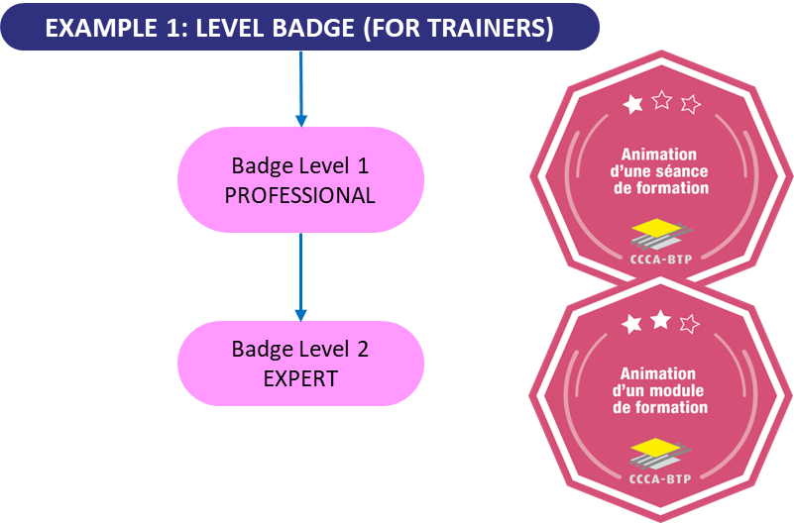

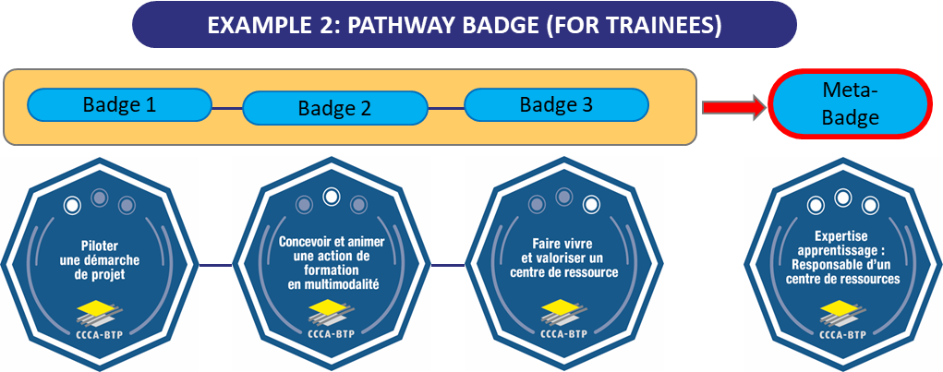

ÉCONOMIE

CIRCULAIRE

ECONOMIE

CIRCULAIRE





ÉCONOMIE CIRCULAIRE

# **Procedure to deliver an Open Badge (Example)**

[Tutorials - Open Badge Factory](https://openbadgefactory.com/en/tutorials/)

1. Go to the site “Open badge Factory” and log in with the credentials that will be previously sent to you.
2. Click on the “Issuer tools” button.



* The list of Open Badges to be issued will then appear (example below):

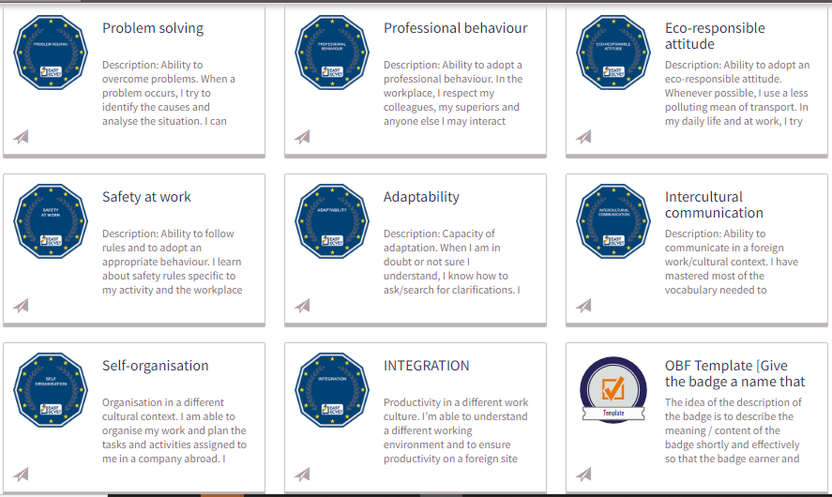

* The 5 different steps to follow will appear at the top of the screen. You must click on each step to go to the next one.



1. In step 2 indicate the requested dates (we will propose 3 years of validity)



1. Add the criteria manually (they do not appear automatically)

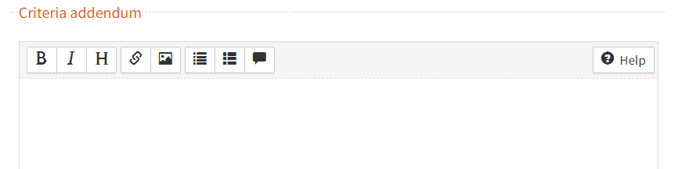

1. Indicate the email address of the beneficiary.



1. Write a short message to accompany the receipt of the badge. For example: "Hello, following *your training named XXXX, you have successfully obtained the following badge "XXXXXXX". You can now download it by clicking on the button below”.*



1. Add a simple text like "get your badge".

The beneficiary then receives an email in which the entire procedure for obtaining the badge is clearly described.

1. The details of this procedure must be defined at each national level.
2. The details of this procedure must be defined at each national level.
3. The details of this procedure must be defined at each national level.
4. The details of this procedure must be defined at each national level.