IO3: Coaching of trainers

Report from CCCA-BTP / France

Transnational context

European project RenovUp -Professionalising site managers and team leaders in the specific control of building renovation works in Europe - Contract no. 2020-1-FR01-KA202-080105 (2020-2023)

IO3. Transnational training programme for teachers, trainers and tutors for the support and training of site managers and team leaders in building renovation works.

National pilot actions: France.

Objective

To develop methodological competences to observe real work situations (on renovation sites) to which site managers and team leaders are exposed in their daily work and to use the results of these observations to design training programmes and contents.

PARTICIPANTS:
- Mickael PRIOUX (BTP CFA PDL), site manager & team leader’s trainer;
- Florent TORREGARAY (prevention, health and safety trainer);
- Caroline PENNERON (painting/coating/finishing trainer);
- Amine SAADAOUI (site planning trainer);
- Maxime KRITHARI (communication trainer) ;
- Frédéric BOUTON (structural work trainer).

TRAINER/ACCOMPANIST:
- Pierre TOUILLON (CCCA-BTP)
- Philippe DREYFUS (BTP CFA PDL)
- Béatrice BEAUJAN (BTP CFA Aquitaine)

Temporalisation and implementation

Inter-session
08/02/2023-27/02/2023
Test o the different grids
Development of training sequences
Work observation in company

Inter-session
08/01/2023-05/03/2023
08/02/2023-05/03/2023
Observation and analysis of work situations on companies
Use of the grids
UNTIL middle of MAY
New work observations
Finalisation of training sequences
Test of training sequences

Stage 1:

- 05/01/2023 in Nantes
- 06 & 07/02/2O23 BTP CFA Gironde in Blanquefort

Stage 1 Teaching/Learning methods and tools (same program in Nantes and Blanquefort)
5 trainers present:
Florent Torregaray (PRP trainer); Caroline Penneron (painting/coating/finishing trainer); Amine Saadaoui (site planning trainer); Maxime Krithari (French/Communication trainer); Frédéric Bouton (structural works trainer).
+ Béatrice Beaujan (educational coordinator)

1st half-day:
- Introduction of the participants.
- Questions "What do you know about RenovUp? It turned out that the protagonists already had a good level of knowledge of the work expected in the RenovUp project. Additional information was provided on the overall framework of the project, its objectives, and expectations.
- Presentation of the RenovUp project (PPT + RenovUp website. It was planned to use the RenovUp website, but it remained inaccessible / problem reported and in the process of being resolved).
- Presentation of the expectations of the experiment (see PPT).
- Discussion of the pedagogical preparation strategy, combining input from the worksite and the requirements of the reference framework to create learning situations. See diagram below (reused during the 2nd half-day).
Work
Situation 1
Work
Situation 2
Work
Situation 3
Referenced learning objective A
Referenced learning objective B
Referenced learning objective C
Learning
Situation
A
Learning
Situation
B

The group redefined what constitutes a work situation (a real site situation involving different players, different tasks and activities, use of different materials and equipment, etc.) and a learning situation (an "imaginary" situation created from real, tangible professional elements with a view to training and achieving educational objective(s)).
- Presentation of the tools (grids 1 and 2) / Explanation and purpose of each tool.
- It was pointed out that all the usage protocols and tools proposed as part of the project were proposals and that the trainers could modify or adapt them, while retaining the "spirit" and purpose of each.
- Grid 1: to collect factual, convincing, realistic information, not necessarily "best practice", and also to identify problems encountered on worksites so that trainees can confront them in training sequences. (Learning by solving problems. Inductive/deductive approach.
- Grid 2: to be used as a diagnostic tool, prior to training. To identify the training needs of each future trainee (identify the training modules in which they will participate)
- Presentation of Open Badges (doc RenovUp)
Ideas emerging from the discussions:
- Organise mobility for CFA staff working on site manager/team leader training courses
- The positioning grid could also be used as a final assessment grid (in particular for obtaining OBs).
2nd 1/day:
Feedback from the previous day:
- The benefits of working in a group (more work and greater efficiency)
- Enrichment of practices through contributions from the RenovUp project
- Combine site observation and trainee monitoring during the same company visit.
- It's a pity that this work didn't start at the same time as the modularisation work undertaken at the CFA.
Morning work :
- Presentation of the monitoring grid. Exchanges and discussion on the evaluation cursor and its meaning (1, 2, 3, 4 or A, B, C, D or other ...). It was specified that, to avoid a "neutral" and uninformative assessment, the cursor deliberately included 4 levels of assessment.
Many questions about the meaning of the grid and its use in a situation. It should be made clear that this is not an evaluation grid (in a negative or connoted sense) but a grid for assessing a degree of mastery and autonomy. It should be used to carry out a formative assessment (see co-assessment): the exchange and the "mark" should provide information on:
- The trainee's strengths (highlighting acquired knowledge);
- Areas for improvement ;
- Avenues for improvement (it is essential to provide these, which is the whole point of this evaluation, integrated into the training process);
- It has been suggested that a "comments" or "other" column be added so that the person carrying out the monitoring can note down any elements that they feel are relevant to the trainee's progress.

- Drawing up a work programme between now and the next meeting:
  - Work on adapting the tools (adapting the grids to the reality of the Blanquefort training centre);
  - 22 Feb: likely company visit by two trainers in pairs (use of grids 1 and 4) BLOCK 3;
  - 21 Feb: likely company visits by two trainers separately, with a joint CR (use of grids 1 and 4) BLOCK 2;
  - Carrying out feedback ;
  - The use of the positioning grid does not seem appropriate, as these young people's training started in September 2022.
The team will be considering the next series of actions to be scheduled in March, April and early May.
- Educational engineering strategy:
- Step 1 Choose the teaching objective(s) for a sequence. Based on the cross-referencing work carried out between the RenovUp reference framework and the training reference framework for team leaders, define the objective of the sequences in order to achieve the targeted pedagogical objective(s) (e.g. interdisciplinary sequences).
- Think about a problem to be solved that is consistent with the objective. Remember, the problem must be engaging to arouse the desire to solve it. It must also be within the trainees' reach.
- Design a realistic learning situation combining "real" elements observed in the field.
- Prepare all the documents for the lesson (course materials, workshop materials, if necessary, assessment tools).
- Test the session on one or more groups.

- Projections for the meeting on 06 and 07 March:
  - Experience feedback to share, analyse and discuss/ Feedback on actions taken.
  - Educational engineering work to create learning sequences.
  - Planning future activities.

INTER-SESSION: 08/01/2023-05/03/2023(PDL) and 08/02/2023-05/03/2023 (BTP CFA Aquitaine)

Test of the different grids/Development of training sequences/Work observation in company

PLACE: On renovation sites and in training centre
During this period, the trainers involved took ownership of the tools. Time was set aside at the training centre for them to work together.
The trainers also went to the company to meet the young people and carry out observations using grid 1.
They also began to draw up training sequences for young team leaders or site managers.

Stage 2:
DATE: 06 & 07/03/2O23 BTP CFA Gironde in Blanquefort
List of participants:
BTP CFA Gironde: Florent Torregaray (PRP trainer); Caroline Penneron (painting/coating/finishing trainer); Amine Saadaoui (site planning trainer); Maxime Krithari (French/Communication trainer); Frédéric Bouton (structural work trainer) + Béatrice Beaujan (educational coordinator)
BTP CFA Pays de la Loire: Philippe Dreyfus (European projects referent); Mickael Prioux (intermediary site maganent trainer)

Programme over two and a half days:
Monday afternoon
  - Introduction
  - Reminder of the experiment and deadlines
  - Feedback on the use of different tools and actions taken
  - Observation and analysis of work situations observed
Tuesday morning
  - Proposed educational use
  - Setting objectives for sequences
  - Development of teaching scenarios
  - Feedback on grid 4 for monitoring and assessing learner progress
  - Inter-cluster work
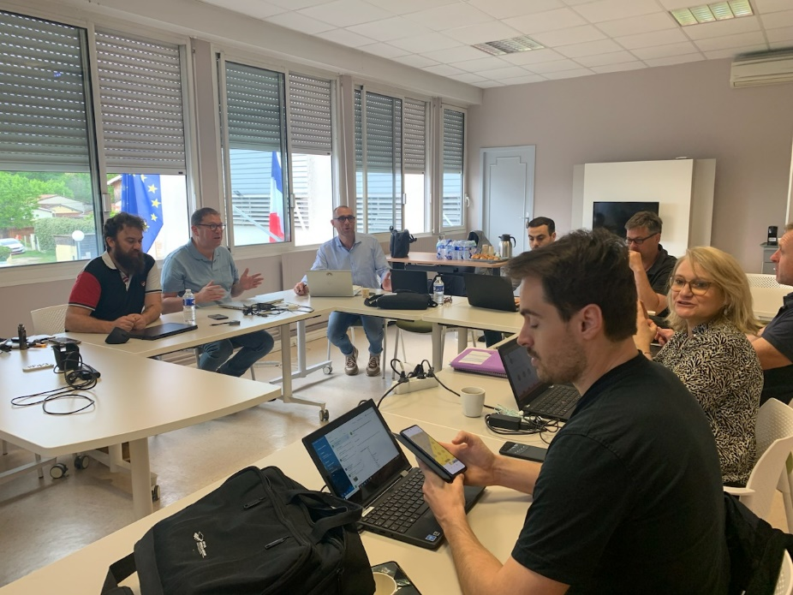

1st half-day :
- Introduction of participants/ Reminder of the 1er group and the actions requested. Reminder of deadlines
- Feedback from participants on actions taken since the first meeting:
BTP CFA Gironde:
The trainers all visited companies to observe work situations using grid 2.
For one pair, a last-minute change led them to a site that was not dedicated to renovation. Despite this, they still used the grid to gather information and concentrated more on the process than on the content. The feedback was generally positive, particularly in the following areas: (forecasting and planning / work organisation / HR management).
Another pair carried out two successive observations on the same day on two different renovation sites (renovation of an old building and extension of an existing building).
Each visit lasted between 2 and 3 hours, in the presence of the trainee and his tutor or MA.
Methodological and practical points raised:
    - Make an appointment with the company no more than 8 days before the visit (to ensure that the appointment is secure, there's no point in making it too far in advance) and tell the company why you're coming: to observe the trainee in a work situation and collect realistic information from the site so that you can develop learning sequences from the field.
    - Adapt the observation grid (delete lines you know you won't be observing) to avoid getting lost during the observation.
    - It's essential to have a dialogue with the people you're working with when you're taking notes.
    - During each observation, one member of the pair conducted the interview and observations, while the other took notes on the fly. They found it difficult to fill in the grid "live", so they preferred to collect all the interesting information and then allocate it to the appropriate boxes on the grid.
    - When the 5 areas of observation were not appropriate or redundancies appeared, they also merged boxes to give a final grid filled and more readable.
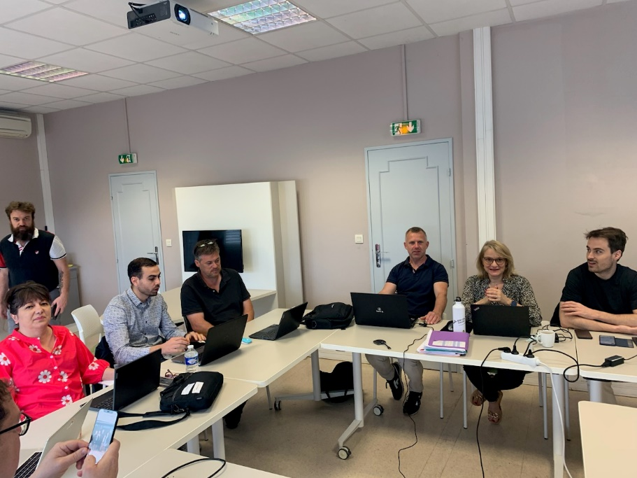

Grid 3 (positioning) was tested on several apprentices and individually.
The content was adapted to the skill blocks chosen (2 and 3), so not all items were covered. One of the users made the following shared point: it is sometimes difficult to decide between the three possible levels of acquisition. The use of this grid did not pose any other problems.
However, while this grid ultimately makes it possible to identify a trainee's training needs or wishes, it does not establish a personalised training plan or pathway. It might be appropriate to provide a supplementary document notifying this.
BTP CFA Pays de la Loire :
Grid 2 had already been tested in November 2022 (see corresponding CR). In addition to taking notes, photos were taken so that they could be used later in the training sequences.
Using the positioning grid (grid 3)
First use: given the deadlines and the difficulty of finding the time to assess each individual, this grid was used with a group of trainees.
The questions were put to everyone, and the first observation was that the young people almost always answered "yes", indicating that they thought they had mastered all the skills.
Mickael and Philippe quickly realised that their choice of a group assessment was not the best one and analysed the situation. The result was that :
    - Young people understand the questions well (and answer them easily, yes) but don't really understand all the skills covered by the wording. By asking additional questions and checking specific points, young people realise that they do not master everything, far from it;
    - It would perhaps be advisable to carry out this assessment in the presence of the teacher and to take the time needed to make a proper diagnosis;
    - The document could be supplemented by a section to assess the trainee's motivation (and that of his or her MA) to follow site manager/team leader training. Identifying an individual's training needs alone is not enough.
Despite this initial, moderately conclusive experience, the tool remains valid, but its 'instructions for use', conditions of use and purpose, which is to draw up an 'individualised training plan', need to be clearly specified.
The following remark, which had already emerged during the first meeting with the BTP CFA Gironde trainers, was made: this grid could also be used as a grid for monitoring the learner's progress. Using the same content throughout the course.
General comment from the discussions: it is not always easy to highlight the specific features of the "renovation site" because they do not appear in each phase in grid 2.
2nd 1/day:
Welcome and brief feedback on the previous day's work:
1er time, Work on grid 4
Spontaneously, grid 4 and its use came up in conversation. Two trainers had tried it out. The BTP CFA PDL team had already expressed their lack of understanding of its use and purpose the day before.
On the other hand, the two teams of trainers spontaneously suggested that grid 3 could perfectly well be used as a training follow-up grid because it followed a content logic that all the participants did not find in grid 4. The surprise and the underlying question were in fact to know why a different formulation and arrangement of skills appeared in grid 4, abandoning the logic used until then with C1, C2, C3, C4.
It was therefore necessary to clarify the following points:
- This grid was based on a proposal from the Italian group and was chosen for its more "company" approach to site management, perhaps closer to the field.
- It is linked to the content of RenovUp by means of the indications in red which refer to the blocks, components, and general teaching objectives.
- Its purpose is to monitor the learner's progress through repeated use throughout the course.
- This is an educational document for use by the trainer.
All of this was not fully understood and/or explained during the first approach.
In any event, the following observations have been made:
    - the use of this grid (at first glance) is confusing for users who do not spontaneously find their way around it. It takes a long time to get used to.
    - The wording of the Items can only be understood by specialists (in education and in the trade).
    - As a result, it is not always understood by the learner and does not provide clear information on progress.
Suggestions and comments:
- The grid needs to be modified so that the monitoring appears on the same document. If you must reuse a new grid for each assessment, it's too cumbersome. If the same grid is used several times (which is simpler), then a solution needs to be proposed (different colour code for each assessment, cursor repeated in each box, etc.) so that both the learner and the trainer can see the progress very easily.
- After each assessment, if it reveals points that need to be reworked, it would be necessary to provide a supplementary document or an additional space on the grid to record the remedial action to be taken.
- As it stands, the grid seems to be aimed more at site managers. There are therefore some "non-applicable" boxes for team leaders. There may be a need to differentiate between .

2nd time, work on the sequences to be developed:
We went back over grids 1 and 2 and the content collected during site visits. A brief reminder was given of the following simplified teaching approach: based on site observations (work situation), a realistic learning situation is developed (to achieve the teaching objectives), leading the trainees to be confronted with one or more problems to be resolved. The approach is to get the trainees to come up with solutions or possible solutions to a problem. In this way, knowledge is co-constructed, and the transmission mode is avoided.
Each team was asked to make suggestions for sequences to be developed and tested over the coming weeks with their apprentices.
Each group worked for 45 minutes. feedback:
For BTP CFA Gironde :
- Preparing a (cross-curricular?) lesson based on the content covered in C2.2 and C2.1.
Theme: drilling openings in an existing building (site co-activity, removal of rubble and other debris, OHS and risk prevention, communication on the site)
Elaboration in March / Possibility of freeing up one or more half-days for joint work for all or part of the RenovUp teaching team. Course planned for mid-April 2023.
- Continuation of company visits with grid 2
- Use of Grid 4 + feedback
For BTP CFA PDL
- Preparing a lesson based on the targeted content C3.3.
Themes: waste management on a renovation site
Preparation in March, course planned for mid-April.
- Continuation of company visits with grid 2 (in particular a new visit to one of the sites visited in November to gather missing information)
- Use of grid 4 + feedback
Please note! For each sequence prepared, it is necessary to produce:
- Documents and teaching aids for trainees
- A description and progress sheet (necessary for sharing with other trainers)
- A report on the use of the sequence with a group.
The next meeting will take place in Blanquefort on 4 (afternoon) and 5 (morning) May, 2023.

Reminder Educational engineering strategy :
- Step 1 Choose the teaching objective(s) for a sequence. Using the cross-referencing work carried out between the RenovUp reference framework and the training reference framework for team leaders, define the objective of the sequences to achieve the targeted educational objective(s) (e.g. interdisciplinary sequence).
- Think about a problem to be solved that is consistent with the objective. Remember, the problem must be engaging to arouse the desire to solve it. It must also be within the trainees' reach.
- Design a realistic learning situation combining "real" elements observed in the field.
- Draw up all the documents for the lesson (course materials, workshop materials if necessary, assessment materials, description and progress sheet).
- Test the session on one or more groups.

INTER-SESSION: 08/02/2023-27/02/2023
Place: in training centre and in companies
Test of the different grids/Development of training sequences/Work observation in company

Time was set aside at the training centre for them to work together.
The trainers also went to the company to meet the young people and continue their observations using grid 1. They also used the other grids (positioning and skills monitoring).
They finalised the training sequences and tested them with the future site managers and team leaders.
Stage 3:
DATE: 04 and 05 May 2O23 / BTP CFA Gironde in Blanquefort
List of participants:
BTP CFA Gironde: Florent Torregaray (PRP trainer); Caroline Penneron (painting/coating/finishing trainer); Amine Saadaoui (site planning trainer); Maxime Krithari (French/communication trainer); Frédéric Bouton (structural work trainer) + Béatrice Beaujan (educational coordinator)
BTP CFA Pays de la Loire: Philippe Dreyfus (European project referent); Mickael Prioux (intermediate site trainer)
Programme over two and a half days:
Thursday afternoon
  - Welcome and presentation of the objectives of the two half-days
  - Progress report on experiments and productions
  - Cross-presentations of the sequences + Feedback on the use of the different tools and actions carried out
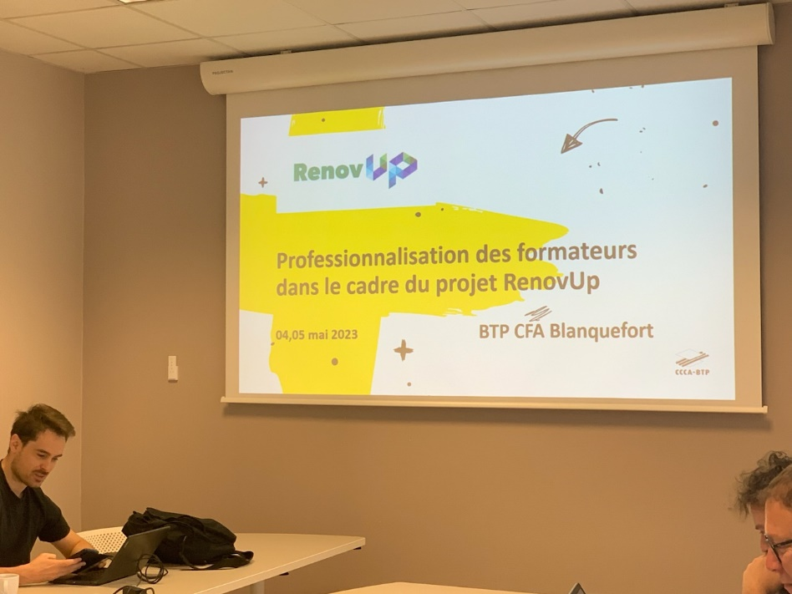

Friday morning
  - Continuation of the previous day's work
  - A look back at the three types of grids
  - Update on Open Badges
  - Briefing + Synthesis
  - Evaluation of the action

Progress report on experiments and productions
  - What sequences (and how many) have you produced and tested
  - Which tools (grids) did you use?
- Pays de la Loire / St Herblain: creation of a complete sequence on the C3.3 component. Supporting documents to come.
Use of grids 1, 3 and 4
- New Aquitaine / Blanquefort: Creation of an interdisciplinary sequence focused on C2.2 but also integrating components of C3 and C2
Use of grids 1, and 4
Cross-presentations of the sequences + Feedback on the use of the different tools and actions carried out. Each training centre presented the documents relating to its sequence and explained how the work had been carried out. Exchanges, questions and remarks took place between the different protagonists.

Cross-presentations of sequences
    - Methodology of development :
.for both groups and both sequences, the methodology developed together during the two previous grouping days was used.

Reminder Pedagogical engineering strategy :
- Step 1 Choose the pedagogical objective(s) of a sequence. Using the cross-referencing work carried out between the RenovUp reference framework and the team leader training reference framework, define the objective of the sequences to achieve the targeted pedagogical objective(s) (e.g. interdisciplinary sequence)
- Think about a problem to be solved in line with the objective. Remember, the problem must be engaging to arouse the desire to solve it. It must also be within the trainees' reach.
- Develop a realistic learning situation combining the "real" elements observed in the field. This situation can be created from several observations of different work sites and contain the problem to be solved.
- Draw up all the documents for the sequence (course materials, workshop materials if necessary, evaluation materials, description and progress sheet)
Test the session on one or more groups:
    - Descriptive sheet / Teaching scenario: it indicates the content and the teaching sequence of each sequence (teaching objective, learning situation, teaching scenario, evaluation)

    - What about the renovation dimension?
This is undoubtedly one of the limits of the experimentation. The components extracted from the content of RenovUp are well integrated into the content of the training courses chosen in the two CFAs. But the focus on the renovation dimension is not always easy to put forward.

Difficulties encountered? Integrating the renovation dimension into training content that was not initially designed for it.

Strong points? In the pedagogical approach, the research of solutions by the whole group of learners is an important vector. The proposals made by the different trainees and discussed together encourage reflection and the acquisition of skills. All participants indicated that in renovation, there is not ONE good solution, but often two or three solutions with their advantages and disadvantages. And for a team leader or site manager, it is in this ability to analyse and choose that his or her competence lies: to analyse the problem encountered, to envisage one or more solutions and to choose the most suitable one, but in a considered and argued manner.

Visits to companies and renovation sites:

    - Difficulties encountered: the interlocutors met are sometimes reluctant to give elements concerning health/safety or waste sorting, because they know that their site is not really in the rules ... and it is of course not easy for them to recognize it. It is therefore necessary to respect and deal with this deficiency.
    - Positive points? Strong points? Visits and observation of building sites, with a focus on "precise training objectives", undoubtedly provide elements to build a realistic training sequence that makes sense for the learner.

A look back at the three types of grids:

- For grids 1 and 2 :
Their usefulness and interest are validated by all the participants. The areas for improvement are mainly in the form. As it stands, the grid is too complicated to be completed on site. On the other hand, it can be used in its current state to record the elements of observation of the various work sites.
Some of the items could be simplified but their sequence provides a good framework for discussion during the site visit.
It is important to go to a site with the objective of the sequence in mind in order to be able to capture the "right elements" to build a future sequence. Collecting for the sake of collecting is counterproductive, you need to collect in a targeted way.

- For grids 3 and 4 (positioning grid and competence monitoring grid)
The general opinion is that the coexistence of these two grids is not necessarily relevant because they overlap.
Grid 3 could be used for its initial purpose (positioning) in the first instance, but also as a monitoring grid later on by modifying it in this sense.
Alternatively, Grid 4 could be adapted to serve both as a positioning grid (with some adjustments) and then as a monitoring grid.
For example, St Herblain used grid 3 for the positioning and then transferred the results to grid 4, then used grid 4 for the follow-up.
Concerning grid 4, the appropriation was not obvious for the participants, but in the end, once its use was understood, it was rather appreciated.

The trainers thus indicate the need to limit the number of tools and increase their efficiency to save time and gain effectiveness.

Update on Open Badges:
The visual of the Open Badges was presented to the participants as well as the content of each OB. The criteria for obtaining them were also given.

More ...
Nothing very specific is envisaged but the desire to use the benefits of the action is there.
For the Loire region, the pedagogical approach will be used again as far as possible, and consideration could be given to creating Open Badges for team leader training.
For New Aquitaine, the sequence will be used again with a new group.
The question was raised as to whether the entire content of RenovUp could be taken up by a training centre in the form of a professional title, for example, or even delivered on an inter-European basis between the 5 partners. There are undoubtedly avenues to be explored ...

Debriefing + synthesis: All the participants had a very positive experience of the professionalization action. The richness of the exchanges and the ease of dialogue were mentioned. The participants mentioned an increase in skills in teamwork and interdisciplinarity.
The time constraint was a bit awkward and participants were sometimes afraid of not being "on target" with the request.
The discovery of new tools and the possibility of appropriating them is seen as a positive point.
"Each meeting was a step up", said one of the participants.
From the facilitator's point of view, despite the initial apprehension of not being able to carry out the experiment within the time limit, it is with great satisfaction that the work carried out by the participants is felt.

